Stuart B. Krost, M.D., P.A.
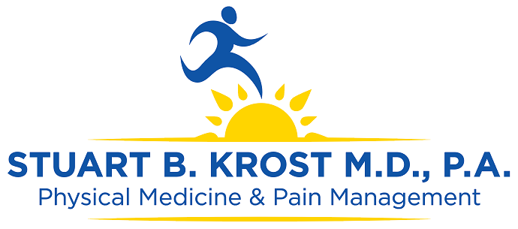

STUART B. KROST, M.D., FAAPM&R, FAAPM, CIME
Physical Medicine & Rehabilitation, Pain Management www.wetreatpain.com

CURRICULUM VITAE
Updated 06-07-2018

Main Office / Administration / Clinical:

•2290 10TH Ave. North, Ste 201 Lake Worth, Fl 33461

Current Professional Addresses:

Satellite/Clinical Locations:

Plantation: 7300 NW 5th St, Plantation FL 33317

Miami: 9220 SW 72nd St, Bldg. 7, Ste 106 Kendal FL, 33173

Ft. Myers: 3615 Central Ave Ste 3, Ft. Myers FL 33901

Port St. Lucie: 1902 SE Port St. Lucie Blvd, Port St Lucie FL 34952

Contact Information:
Phone: 561-296-2220

Fax: 561-296-2221

E-mail: skrost@aol.com

Name: Stuart B. Krost, M.D. DOB: Febuary 25th, 1962, USA Marital Status: Married, Two Children

College:

Medical School:

Internship (Surgical):
State University of New York at Stony Brook
Long Island, New York
Honors Graduated Cum Laude
Phi Beta Kappa
Dean's List, Sigma Beta Honor Society
June, 1985
B.S., Biochemistry

State University of New York at Syracuse
Syracuse, New York
May, 1988
Doctor of Medicine

North Shore University Hospital
Affiliate of Cornell University Medical
Manhasset, New York
1988-1989
General Surgery Internship

Residency:

Special Service:

*Board Certification:
State University of New York
Health Science Center at Brooklyn
Brooklyn, New York
1991-1992
Chief Resident

Liason of SUNY HSC at Brooklyn to the American
Academy of Physical Medicine and Rehabilitation

•Physical Medicine & Rehabilitation 1993-Present (Re-Certified 2012)
•Pain Management 1992-Present
•Southeastern Neuroscience Institute:
Certification in Thermography Interpretation 1994
•Certified Independent Medical Examiner (CIME) 1999-Present (Re-
certified in 2009)

Licensure: Florida State Medical License:
# ME0061951

Professsional Memberships:
• The American Academy of Pain Management
• The American Academy Physical Medicine and Rehabilitation
• The American Medical Association
• The American Board of Independent Medical Examiners
• Palm Beach County Medical Society
• Florida Medical Society, Florida Society of PM&R

Professional Titles: 1998-Present: Chief Medical Officer of the State of Florida for Inpatient and Outpatient care for HCR/Manor Care

1996-Present: Medical Director of CARF, Accredited Pain
Program for Heartland Pain & Rehab.
1996-Present: President of Tierra Del Rey Community
Association
1996-1998: Treasurer of Tierra Del Rey-North Community
Association
1998-Present: Vice President of Tierra Del Rey-North
Community Association
1998-Present: Director, Board of Directors of Urecords
International
1996-1998: Physician of HCR/MANOR CARE

1995-1996: Rehabilitation Director of HIS West Palm Beach-

1992-1996: Private Practice-Partnership

1996-Present: Solo Practice (The Offices Of Stuart B. Krost, M.D., P.A.)

Hospital Affiliations: Special Interest:
•Pinecrest Rehabilitation Hospital
•Delray Community Hospital

Acute and Chronic Pain Management

Sports Medicine

Electrodiagnostic Studies: EMG / NCV Interventional Therapies
Orthopedic Rehabilitation

General Rehabilitation

3

